**Commodore Port Breakout: Cassette Breakout Rev. 0**

**Module Description**

# Introduction

This assembly serves as a breakout board for the Commodore PET Cassette Port. It is also suitable for the C64, C128 and VIC-20 cassette port. The purpose is connecting it to the Cassette Port Output board via a ribbon cable.

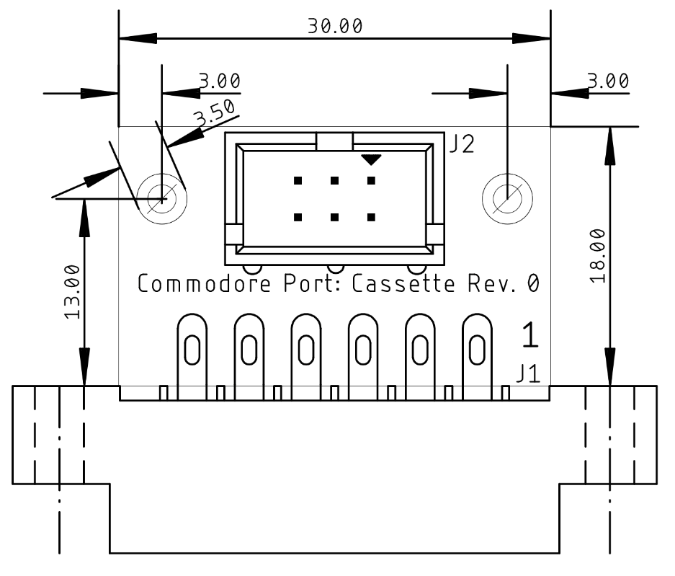

Figure 1: Dimensions of the PCB

# Connector Pinout

|  |  |  |
| --- | --- | --- |
| J1 | Cassette Port | J2 |
| 1 | GND | 1 |
| 2 | +5V | 2 |
| 3 | MOTOR | 3 |
| 4 | READ | 4 |
| 5 | WRITE | 5 |
| 6 | SENSE | 6 |
| A | GND | - |
| B | +5V | - |
| C | n.c. | - |
| D | n.c. | - |
| E | n.c. | - |
| F | n.c. | - |

# Revision History

## Rev. 0

* Prototype